Reproduction Web-exploration

Directions: As you read the following information and visit the following sites answer the questions in the boxes along the way. Copy/paste the links in your CHROME web browser.

A Brief Summary of Some Main Points Regarding Asexual Reproduction:

1. the production of offspring that are genetically identical to the parent organism
2. only one parent involved
3. does not provide any genetic variation among individuals of a species
4. maintains beneficial traits in all offspring
5. generally used by less complex organisms

Important Background Information:

* Cells contain genetic information in a substance called DNA.
* Chromosomes are the structures found in the nucleus of a cell that contain DNA.
* A copy of a chromosome can be made during a process called replication.
* When one cell divides into two identical cells, each cell gets a copy of each chromosome.
* **Mitosis** is the name given to the process of one nucleus splitting into two identical nuclei.
* Mitosis is critical for asexual reproduction.

Task 1. Lets learn more about MITOSIS

A. watch a video of mitosis in a real cell

<http://iknow.net/player_window.html?url=media/prophase_video_auto.swf&width=360&height=285>

B. Watch mitosis again at another site!

<http://www.pbs.org/wgbh/nova/baby/divi_flash.html>

C. Visit the “Cells Alive” website. [www.cellsalive.com](http://www.cellsalive.com)

- When you are there, click on **cell biology** on the left side of the screen.

- Then select **Mitosis**.

- Watch the video and read over the description of the process of Mitosis.

- Write a **brief** description of the process of Mitosis.

WRITE YOUR DESCRIPTION HERE:

Task 2. Various organisms reproduce asexually without using Mitosis.

This section allows you to investigate these processes.

**A. Binary Fission:** Bacteria and Amoeba are two examples of organisms that reproduce asexually by binary fission

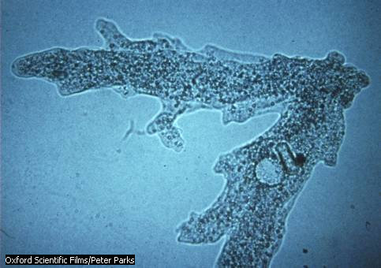

- Visit this site to see bacteria using binary fission: <http://www.emc.maricopa.edu/faculty/farabee/BIOBK/BioBookmito.html>

- Scroll down to PROKARYOTIC CELL DIVISION and watch cell division.

1. List the 4 steps of cell division as shown in the YELLOW animation.

**B. Budding:** yeast is an example of an organism that reproduces asexually by budding.

- In this photo the large cell on the bottom is currently budding. The large cell in the top middle has already budded several times (notice the pock mark scars where buds have formed and separated.

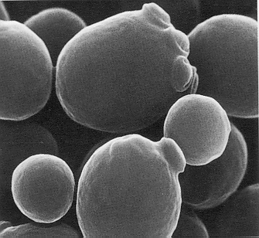

Key Points:

* Parent organism divides into two unequal parts
* Buds break off and live independently
* Buds grow in size and can then have their own buds
* The nuclei of both the parent and the daughter are identical

Yeast budding

1. Describe how this type of reproduction would benefit the yeast?

2. Explain WHY a yeast would have to perform this type of reproduction…

**C. Vegetative Reproduction:** Plants often use this to reproduce asexually.

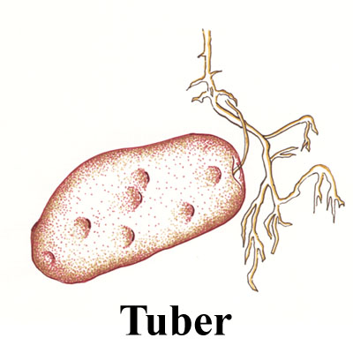An overview: Vegetative, or asexual, reproduction is the reproducing of plants using vegetative tissues (i.e., not involving sexual reproduction). This results in a plant that is genetically identical to (i.e., a clone of) the original 'donor' plant. Vegetative reproduction occurs both naturally and artificially. It is a very common practice in farming for reproducing plants with particularly good characteristics, and is used extensively with some species in potato farming and forestry, particularly in high productivity, fibre farming systems (e.g., plantations of hybrid poplars, eucalyptus, southern US and Caribbean pines).

A tuber, like this **potato**, is a great example of this:

wikipedia’s [thoughts on vegetative reproduction](http://en.wikipedia.org/wiki/Vegetative_reproduction)

1. What are some cultivated plants propagated by vegetative methods?

**D. Fragmentation:**

On the John Friedmann website (<http://johnfriedmann.com/biogloss/Reproduction-whatis.htm>) there is a slide show about reproduction in which you can read about the different type of reproduction.  Click through the presentation (Ch 2 and 3 only) and answer the questions below.

1.How can starfish reproduce asexually by fragmentation (explain the process)?

2. Although a starfish can reproduce this way, it prefers to reproduce sexually. Why?

Task 3: Meiosis and Fertilization

1. Learning about Meiosis.

* You will look at the website (<http://johnfriedmann.com/biogloss/Meiosis.htm>) for reproduction and describe why meiosis is important for organisms that reproduce sexually.

1. Why is it important for organisms that reproduce sexually to go through meiosis?

1. External VS. Internal Fertilization

* Organisms that reproduce sexually will have fertilization take place either internally or externally. To read about internal and external fertilization methods visit: <http://johnfriedmann.com/biogloss/Fertilization.htm>

1. Describe internal and external fertilization.
2. Give examples of organisms for each method.

**Some Extra Fun :)**

* 1. Go back to the “cells Alive site and find the “puzzle” section.
  2. Complete the crossword on **MITOSIS** (or click this address): <http://www.cellsalive.com/puzzles/mitosis/index.html>
  3. These links offer some amazing video of mitosis taken from the iKnow digital media website. If you would like to, please feel free to visit this site after you have view these videos. Please turn your volume on to listen to explanations easily.

1. A great example of mitosis in plants can be seen here: <http://iknow.net/mitosis_video_landing.html?movie=media/plant_mitosis_click.swf&title=Mitosis%20in%20a%20Plant%20Cell&gclid=CO-fpdujgo8CFQp7PAodqhFd4A>
2. The cell cycle is explained again at this site: <http://iknow.net/player_window.html?url=media/cell_cycle_intro_auto.swf&width=360&height=285>
3. To see a zygote dividing through mitosis, go here: <http://iknow.net/player_window.html?url=media/fish_development_auto.swf&width=360&height=285>
   1. Still have time?? Take the Cells Alive Cellular Biology Quiz at this site. Try to do better than Nickel's 9/10! <http://www.cellsalive.com/quiz1.htm>
   2. Use this memory game to learn your cell organelles!! <http://www.quia.com/cc/2744.html> and for some extra O.T.T. fun: go to games and do a crossword!