Science 9 Physics Notes Lesson 1 Name:
Static!

Objectives: By the end of the lesson you should be able to:
________________________________________________________________________________________________________________________________________________________________________________________________________________________________________________________________________________________________________________________________________________________________________________________________________________

Physics Intro
- Physics: the study of __________________________ and its uses
- For this unit we will be focusing on _____________________________Energy

Electricity
- Electricity is the study of the ______________________ and its uses
  - What is an electron?
  - Where is electricity used?
  - Why do we get shocked?
  - How do light bulbs work?
  - How does electricity actually flow?

Remember…
- An atom has _____ subatomic particles
_____________________ _____________________ __________________
- There are positive and negative charges
- ______________________ move fairly easily – Proton and neutrons do not!
- Add electrons = _______________________
- Remove electrons =_____________________

Electrostatics
- Electrostatics = the study of ____________________ electrons
- The Laws of Electrostatics:
  - Opposite charges _______________
  - Like charges _________
  - Neutral objects are _________________ to any charge
- An ____________________ ________________ results from the movement of electrons by charged objects nearby, not by direct contact!
- An __________________________ measures the amount of static electricity

The Coulomb!
- Charles Coulomb: lived during the 1700s
  - Developed a way to measure the __________________ of electrons
  - Named the unit the Coulomb (C)
  - One C equals 6.24x10¹⁸ charges
Since 1 electron = 1 negative charge
1 C = 6.24 x 10¹⁸ electrons That’s a LOT of electrons!!
Creating Static Electricity
- _________________________between two objects causes one object to ____________ electrons and the other object to ___________ electrons

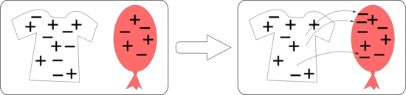

Measuring Static Electricity: use an _______________________________

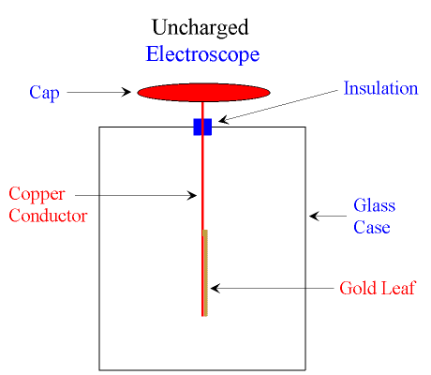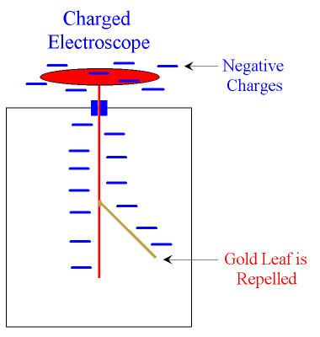

Transferring Static Electricity

Conduction:
- A charged object _________________ another object and __________________ electrons
Induction:
- A charged object ________________ ____________ another object and a charge results

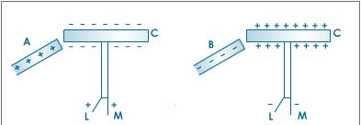
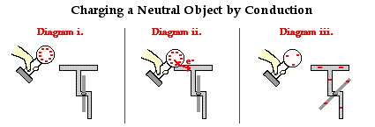

Conductors
- Allow electrons to _______________ freely
- _______________ are excellent conductors because they can ___________ electrons easily

Insulators
- Do not allow __________________ to move freely
- Glass, plastics, ceramics and dry wood are good insulators

Dangers of Static Electricity
- ____________________ can build up charges via friction between their tires and the road
- Thus they have to _______________ the charges before they fuel up or else…
- ____________________ must also do this!
- Lightning rods are placed on top of buildings to protect them from lightning

_______________________: provides a path to the Earth (ground)

