Science 9 Ecology Notes Lesson 2 Name:
Carbon Cycle!

Objectives: By the end of the lesson you should be able to:
________________________________________________________________________________________________________________________________________________________________________________________________________________________________________________________________________________________________________________________________________________________________________________________________________________

Carbon Cycle
- Stored in _____________ in _________________
- Gigatonnes: billion tons of nutrient
  - 16 gigatonnes = 16 000 000 000 tons

- Sinks: places where nutrients ____________________
  - Nutrients flow into and out of sinks
  - Major sinks: ____________________________
___________________________
___________________________
___________________________

General Nutrient Cycle Overview

Carbon Cycle
- Choose 4 colours and colour the legend below:

  - Sinks □
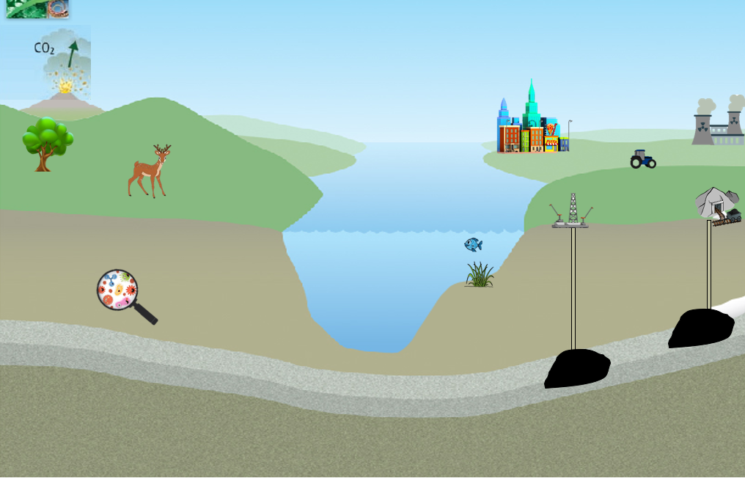
  - Natural pathways □
  - Human pathways □
  - Extra labels (any extra info) □

