Sci 9 Chem 7 Notes Name:

Objectives: By the end of the lesson you should be able to:
________________________________________________________________________________________________________________________________________________________________________________________________________________________________________________________________________________________________________________________________________________________________________

Covalent Compounds
- What happens when 2 _________________________ try to bond when they both need to _________ electrons?
  - They have to ______________________ electrons to gain ______________ outer shells!
  - A ____________________________ is formed when a group of atoms bond together by _____________________ electrons

Covalent Bonding Example: WATER (H₂O)
Draw a Bohr model diagram for hydrogen and oxygen

- How many valence electrons does hydrogen have?

- How many valence electrons does oxygen have?

- When hydrogen and oxygen bond how many electrons does oxygen need?

- How many electrons can hydrogen give to oxygen?

- So how many hydrogen atoms are needed to make water?

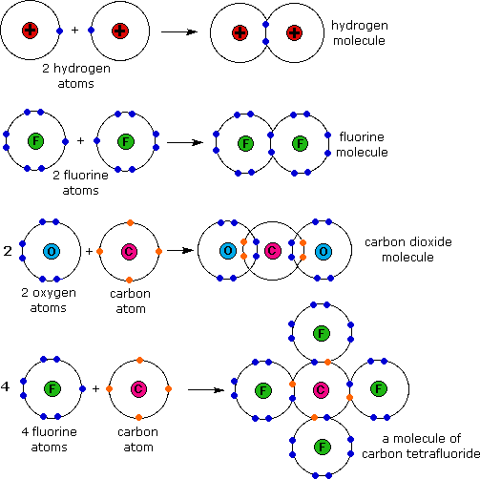
Notice that the outer shells of each atom are __________________________________to show and that the electrons are in that “_________________ ____________”
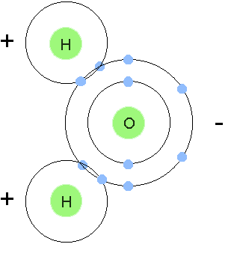

Ionic Vs Covalent Compounds
 | IONIC | COVALENT
SIMILARITIES
DIFFERENCES

