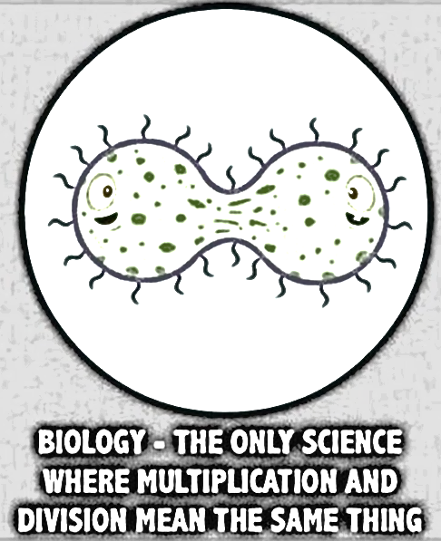

BIOLOGY

Biologist: ________________
Block: ______

