Science 9 Biology Notes Lesson 3 Name:
Cell Cycle & Mitosis!

Objectives: By the end of the lesson you should be able to:
____________________________________________________________________________________________________________________________________________________________________________________________________________________________________________________________________________________________________________________________________________________________________________________________________________________________________

Cell Division Rates:
- Cells divide at different rates:
  - Brain cells: every __________________
  - RBC: every ____________
  - Skin cells: every ____________
  - Liver cells: every _______________
  - Stomach lining: every __________!
  - Intestinal lining: every ______________!

Cell Division:
- When a cell reaches the point at which the ___________________ is no longer able to sustain the ________________, the cell divides!
- By dividing, the cell produces 2 new, _______________ cells with an adequate amount of cell membrane to maintain the cytoplasm

Types of Cells:
Body Cells (AKA ___________)
- Make up all body _____________________
- In each cell there are _________ chromosomes
- There are ______________ of chromosomes
- One of each pair comes from each ______________ (i.e. 23 from mom and 23 from dad for a total of 46)
Sex Cells (AKA ________)
- Make up ______________ (egg and sperm only)
- Contain _______ chromosomes
- WHY?

Cell Division:
- Both of these cells have to reproduce and _____________ but they do it in very different ways
- Body Cell Division = ________________
- Sex Cell Division = ______________ (more on this next class!)

Somatic Cells:
- Life cycle of a____________ cell
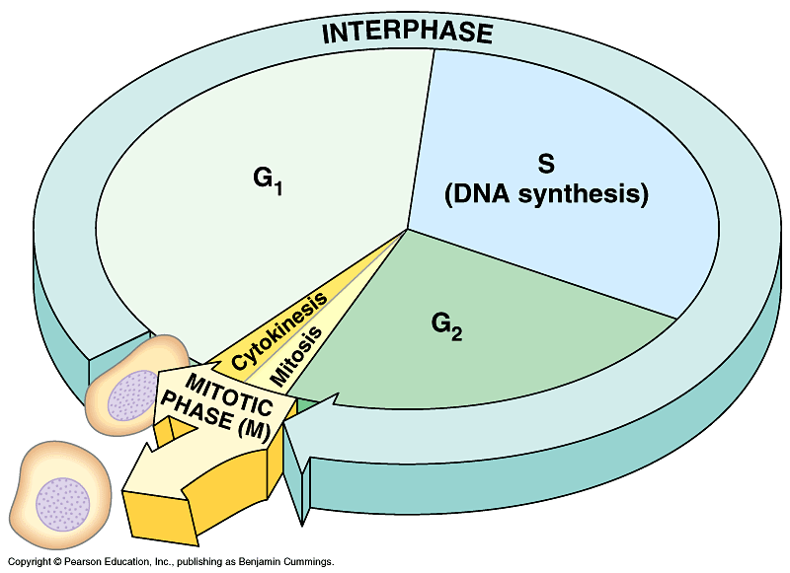
- Has 3 stages: ________________________, __________________, and ___________________

Cell Cycle:
- Interphase
  - Growth and prep
  - DNA rep
  - Growth and prep
- Mitosis
- Cytokinesis

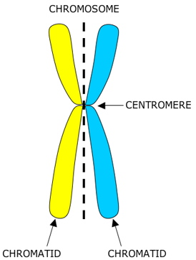

Mitosis:
- Division of the______________ and its contents
- Makes _______________________ that are _________ to the parent cell
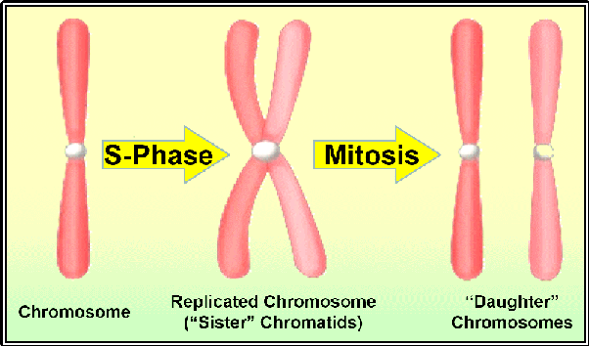
- Has 4 stages:
  - _________________
  - _________________
  - _________________
  - _________________

Pneumonic
I
P
M
A
T
C

Cell Cycle:
Order of events:
Interphase
Prophase
Metaphase
Anaphase
Telophase
Cytokinesis

Stages of Mitosis:
Prophase
- Chromosomes __________________ and become visible
- ____________________ move to poles and make _______________________________
- Nuclear membrane ___________________
Metaphase
- Chromosomes line up along _____________________________________
Anaphase
- _________________________ pull chromosomes ______________and towards the poles
Telophase
- Nuclear envelope ___________________ around each set of chromosomes
- Chromosome begin to _____________________________
- __________________________ break down

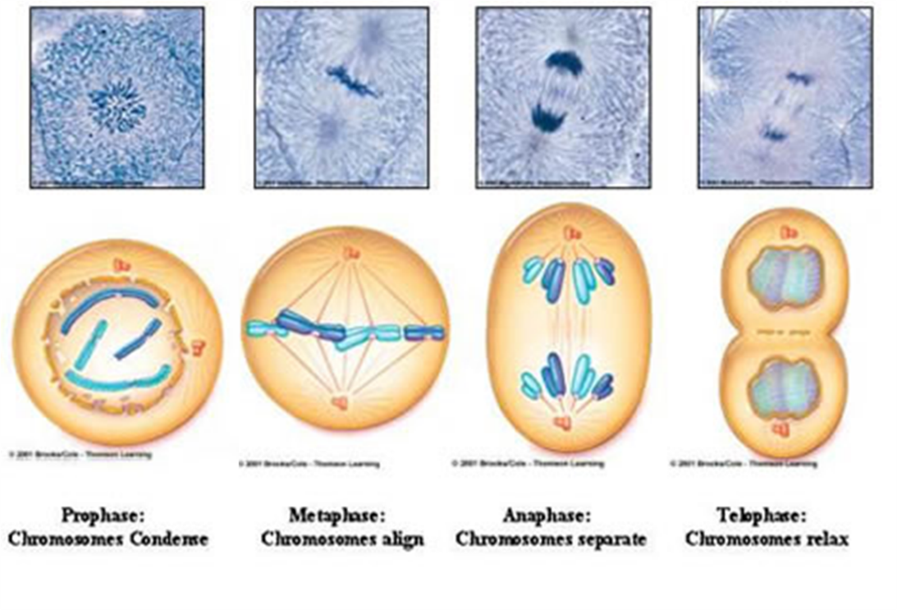

Cytokinesis:
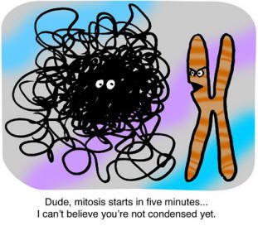
- The cells _____________________ forming two new daughter cells that are identical to the parent cell

