Science 9 Biology Notes Lesson 2 Name:
DNA!

Objectives: By the end of the lesson you should be able to:
________________________________________________________________________________________________________________________________________________________________________________________________________________________________________________________________________________________________________________________________________________________________________________________________________________

The Nucleus:
- What does it do?

- How does it do this?

DNA Discovery:
James Watson & Francis Crick:

Rosalind Franklin:

Linus Pauling:

DNA and Chromosomes:
- DNA: the _____________________ of life!
- Located in the nucleus in ______ “chunks” called Chromosomes
- Each chromosome has sections that codes for a specific __________________________
- These sections are called genes

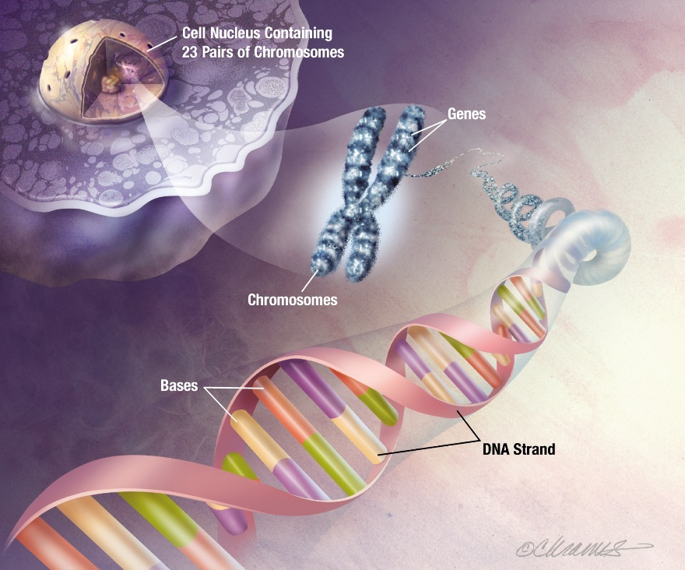

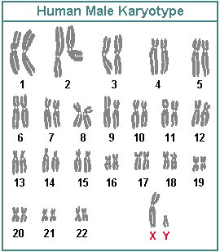
Human DNA
- Humans have _________ chromosomes
- That is: _______ __________ of chromosomes
- ______ from mom and ______ from dad

DNA Structure:
- Double_____________
- Sugar-phosphate _______________
- _____ bases
- Complementary base pairing
______________ _______________
