Resistors in Series and Parallel
Name: ____________________
Date: ____________________
Block: _________

Purpose: Resistors slow down the flow of charge and change electrical energy into other forms of energy. By connecting resistors in different configurations, you can control both current and energy in the circuit. In this investigation, you will build both series and parallel circuits involving resistors. By measuring the current and voltage, you can use Ohm’s Law to calculate resistance.

Safety:
- Disconnect the circuit if any component becomes hot.
- Be sure to turn off the power supply while constructing the circuit.

Materials:
- Power supply | - Ammeter | - 3 resistors of different sizes
- Voltmeter | - Knife switch | - Connecting wires

Procedure:

Part 1 – Resistors in Series
- You will need the following data table for data entry:

Resistance (Ω) | Voltage (V) | Current (A)
Resistor 1 = | Voltage across  resistor 1 = | Total current leaving the battery =
Resistor 2 = | Voltage across  resistor 2 =
Resistor 3 = | Voltage across  resistor 3 =
Voltage across
battery =

- Using the resistor colour code, determine the resistance of each resistor. Record these values in your data table.

- Construct the circuit shown below. The “battery” in the circuit is the power supply.
DO NOT touch the dials on the power supply!! It is set where it needs to be!!
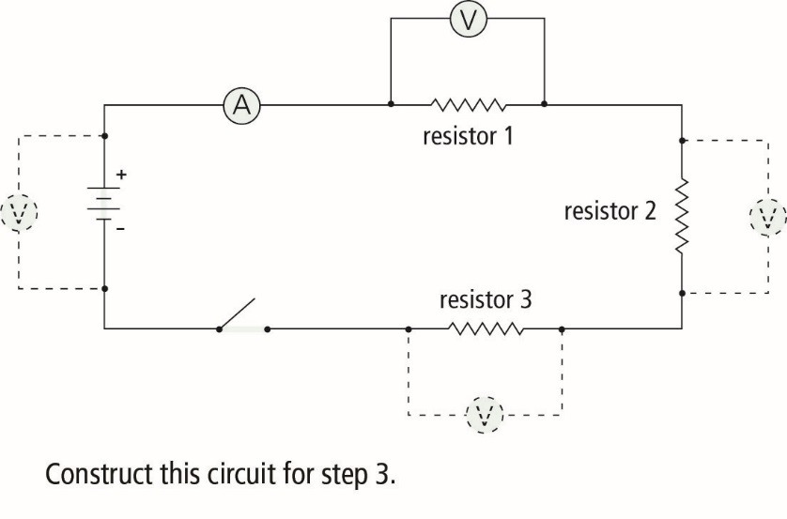
- Close the switch, and measure the current through the ammeter. Record this current in your data table.

- Measure the voltage across resistor 1. Record this in your data table.

- Move your voltmeter, and measure the voltage across the remaining resistors and battery. Record each measurement in your data table.

- Open the switch, and disassemble your circuit.

Part 2 – Resistors in Parallel

- You will need the following data table for data entry:

Resistance (Ω) | Voltage (V) | Current (A)
Resistor 1 = | Voltage across  resistor 1 = | Total current leaving the battery =
Resistor 2 = | Voltage across  resistor 2 =
Voltage across
battery =

- Using the resistor colour code, determine the resistance of each resistor. Record these values in your data table.

- Construct the circuit shown below. The “battery” in the circuit is the power supply.
DO NOT touch the dials on the power supply!! It is set where it needs to be!!

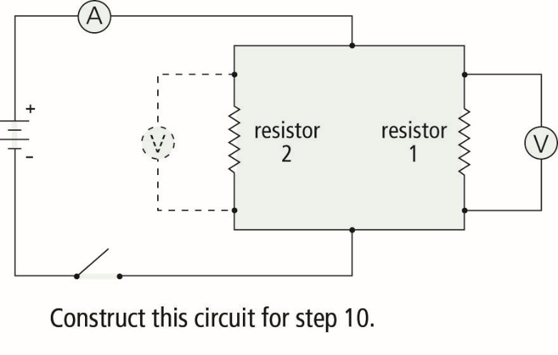

- Close the switch, and measure the current through the ammeter. Record this current in your data table.

- Measure the voltage across resistor 1. Record this in your data table.

- Move your voltmeter, and measure the voltage across resistor 2 and the battery. Record each measurement in your data table.

- After you have taken all measurements, open the switch.

- Clean up and put away the equipment you have used.

Analyze (*answer on a separate piece of paper)

Part 1
- Use Ohm’s Law $\left(R=\frac{V}{I}\right)$ to calculate the total resistance of your series circuit. (Use the battery voltage and the current leaving the battery.)

- Compare the total resistance calculated in question 1 to the individual resistors used in the circuit. Is the total resistance greater or less than the individual resistors?

- Compare the voltage across each resistor. Does each resistor lose the same amount of voltage?

- Add the voltages on each of the three resistors. Compare the total voltage lost on the three resistors to the battery voltage.

Part 2
- Use Ohm’s Law to calculate the total resistance of your parallel circuit. (Use the battery voltage and the current leaving the battery.)

- Compare the total resistance calculated in question 5 to the individual resistors used in the circuit. Is the total resistance greater or less than the individual resistors?

- Compare the voltage across each resistor. Does each resistor lose the same amount of voltage?

Conclude and Apply
- States the relationships of the following terms in a series circuit: total resistance, individual resistors, total voltage, and voltage across each resistor.

- State the relationships of the following terms in a parallel circuit: total resistance, individual resistors, total voltage, and voltage across each resistor.

