Resistors & Ohm’s Law
Name: ____________________
Date: ____________________
Block: _________

Purpose: In Part 1 of this activity, you will construct a circuit from a circuit diagram and measure voltage and current using a multimeter. In Part 2, you will calculate resistance.
Safety:
- If any of the wires or resistors become hot, open the switch immediately.
- Make sure that the positive terminal of the ammeter is connected to the positive terminal of the battery. The negative terminal of the ammeter should be connected to the negative terminal of the battery.
- Never connect an ammeter directly across the terminals of the battery.
- There must be a load, in this case a resistor, in the circuit to limit the flow of electrons.
Materials:
- 2 different resistors  - Knife switch | - Multimeter | - Wires  - Four 1.5V batteries
Procedure:
Part 1 – Measuring Voltage and Current
- Use the following data table to record your results.

Resistor Value  (Ω) | Voltage  (V) | Current  (A) | Calculated Resistance  (Ω) | Average Calculated Resistance  (Ω)
#1

(from colour code)
#2

(from colour code)

- Using the resistor colour code, record the value of each resistor in your data table.

- Construct the following circuit using one of your resistors and ONE 1.5 V battery. Be sure to leave the switch open until you are ready to take a reading.
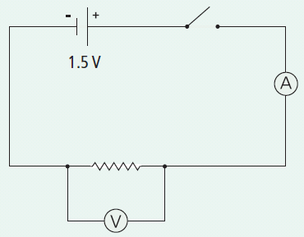

- Close the switch briefly and take your measurements:
- Measure the voltage across the resistor (on the 20V setting). Record the value.
- Measure the current in the circuit (in the mA settings). Record the value. You must convert to A first, though!

- Replace your 1.5 V battery with TWO 1.5 V batteries connected together. Make sure the batteries are connected positive to negative. Repeat step 4.

- Connect THREE 1.5 V batteries together, again positive to negative. Repeat step 4.

- Connect FOUR 1.5 V batteries together, again positive to negative. Repeat step 4.

- Remove your first resistor and replace it with your second resistor. Repeat steps 4 – 7.

- Clean up and put away the equipment you have used.

Part 2 – Calculating Resistance (*show calculations on a separate piece of paper)

- Using your measured voltage and current, calculate the resistance for each set of data (remember the Ohm's Law triangle). Record these values in the “Calculated Resistance” column of your data table.
Analyze
- Using the calculated resistances for resistor #1, calculate the average resistance. Record this value. Include correct units.

- Using the calculated resistances for resistor #2, calculate the average resistance. Record this value. Include correct units.

Conclude and Apply
- For each resistor, compare the average value of the resistance to the value obtained from the colour code.

- Give a possible reason for the calculated value and colour code value not being exactly the same.

- As the current through an individual resistor increased, what happens to the voltage across that same resistor?

- What can you conclude about the relationship between voltage, current and resistance in a simple series circuit?

